# Exp 2a – Guessing Game

# Program:

clear

a=$(($RANDOM%10))

echo ""

echo " Guessing Game "

echo " Note: Guess a Numer less than 10/n"

echo ""

echo "Enter your Guess"

read b

if [ $a -eq $b ]

then

echo "Your Guess is Correct"

else

echo "Better Luck Next Time!"

echo "The answer is $a"

fi

# Output:

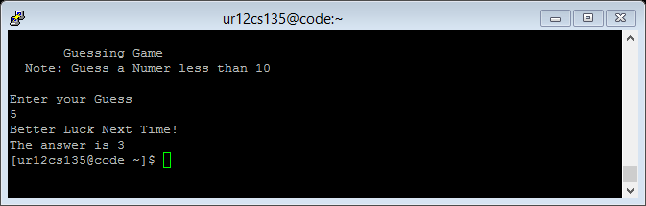

# Exp 2b – Continuous calculator

# Program:

clear

echo ""

echo " Basic Operations"

echo "1.Addition 2.Substraction 3.Multiplication 4.Division note: Press q at anytime to exit"

echo ""

echo "Enter first Operand"

read a

while true

do

echo "Enter next Operand"

read b

if [ $b = q ]

then

exit

fi

echo ""

echo "Select among above Operation"

read num

case $num in

1) c=`expr $a + $b`;;

2) c=`expr $a - $b`;;

3) c=`expr $a \* $b`;;

4) c=`expr $a / $b`;;

q) exit;;

*) echo "Try Again! Invalid Option";;

esac

a=$c

echo "Res: $c"

echo ""

done

# Output:

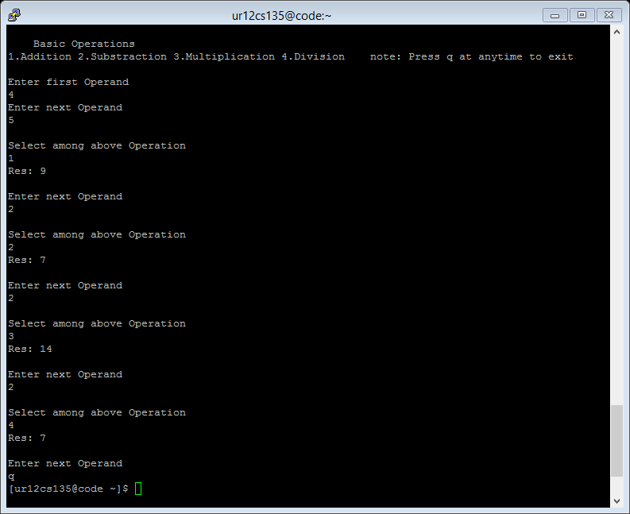

# Exp 2c - Pattern

# Program:

clear

echo ""

echo "Enter Number of Lines to Print The Pattern"

read a

for (( i=-1 ; i<$a ; i++ ))

do

echo -n "*"

done

b=a-1

echo ""

for (( j=$a ; j>0 ; j-- ))

do

for (( k=0 ; k<$j ; k++))

do

echo -n " "

done

echo "*"

done

for (( i=1 ; i<=$a ; i++ ))

do

echo -n "*"

done

echo ""

# Output:

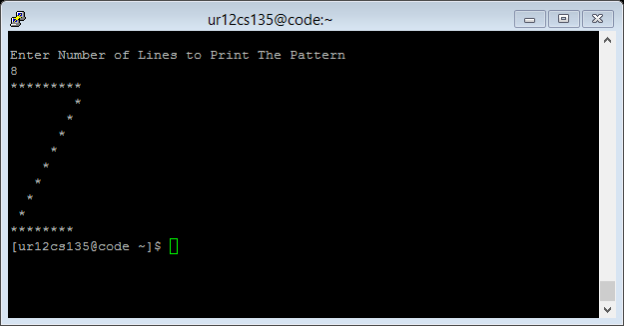

# Exp 2d – Bank Account

# Program:

clear

echo "Enter your name"

read name

balance=0

echo ""

until [ $balance -gt 500 ]

do

echo "Enter the initial deposit amount Note: Should be greater than 500"

read balance

done

echo""

select choice in Deposit Withdraw CheckBalance Exit

do

echo ""

case $choice in

Deposit)

echo "Enter the Amount you want to Deposit"

read c

balance=`expr $balance + $c`

echo "The remaining balance is: $balance"

echo ""

;;

Withdraw)

while true

do

echo "Enter the Amount you want to Withdraw Note: Should be less than the Balance remaining"

read c

if [ $balance -gt $c ]

then

break

fi

done

balance=`expr $balance - $c`

echo "The remaining balance is: $balance"

echo ""

echo ""

;;

CheckBalance)

echo "The remaining balance is: $balance"

echo ""

;;

Exit)

exit

;;

*)

echo "Invalid Option"

;;

esac

done

# Output:

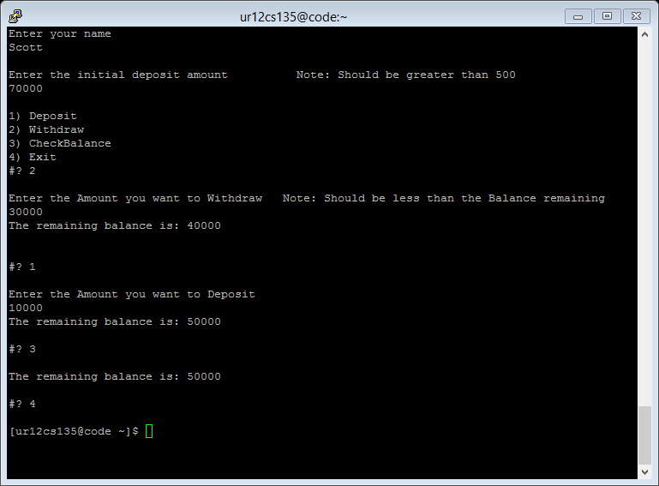

# Exp 2e – File Operations

# Program:

clear

select choice in Create Read Append Delete Exit

do

echo ""

case $choice in

Create)

echo ""

echo "----Create----"

echo "Enter file name"

read a

echo "Write the Content Note: Press ctrl+D to close the file"

echo ""

`cat > $a`

;;

Read)

echo ""

echo "----Read-----"

echo "Enter file name"

read a

echo ""

cat a

echo ""

;;

Append)

echo ""

echo "----Append----"

echo "Enter file name"

read a

echo "Enter the data to append"

echo ""

cat a

`cat >> $a`

;;

Delete)

echo ""

echo "----Delete----"

echo "Enter file name"

read a

echo ""

`rm $a`

;;

Exit)

exit

;;

*)

echo "Invalid Option! Try Again..."

;;

esac

echo ""

done

# Output:

